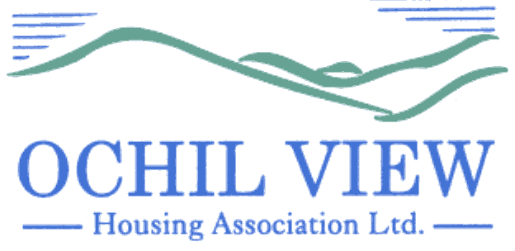
NOTICE OF BOARD OF MANAGEMENT MEETING TO BE HELD AT OCHIL HOUSE, ALLOA AND REMOTELY (VIA MS TEAMS) ON THURSDAY 25th APRIL 2024 AT 6PM

AGENDA

- Recording of Meeting (No Papers)
FOR APPROVAL / TO BE MINUTED

- Apologies

- Declarations of Interest (No Papers)
TO BE RECORDED

- Minutes of Board of Management Meeting held on 28th March 2024 (Enclosed)
FOR APPROVAL AND SIGNATURE

- Matters Arising from Agenda Item 4.0

- Private & Confidential Minutes of the Board of Management Meeting held on 29th February 2024 (Enclosed) FOR APPROVAL AND SIGNATURE
(approver and seconder omitted at meeting on 28th March 2024)

- Minutes of the Executive Committee Meeting held on 14th March 2024 (Enclosed)
FOR APPROVAL AND SIGNATURE
(approver and seconder omitted at meeting on 28th March 2024)

- Policy Amendment Report (Report from the Chief Executive) FOR APPROVAL

- Corporate Management Plan (1st Draft) (Report from the Chief Executive) FOR APPROVAL

- Minutes of the Customer Services Committee Meeting held on 11th April 2024 (Enclosed) FOR INFORMATION

  - Verbal Update from Convenor
  - Abandoned Property Policy Review FOR APPROVAL
  - Planned Maintenance Policy Review FOR APPROVAL

- EVH Matters:

  - EVH Monthly Report: April 2024 (Enclosed) FOR INFORMATION
  - EVH Nominations–Executive Committee (Enclosed) FOR CONSIDERATION

- Governance / Committee Training Issues
  - Board Member Appraisals 2024 (Verbal Update) FOR INFORMATION
  - SFHA Annual Conference 11/12 June (Enclosed) FOR INFORMATION
  - Audit Plan 2024 (Enclosed) FOR INFORMATION
  - Regulatory Engagement Plan 2024 FOR INFORMATION

- A.O.C.B

- Date of Next Meeting 30th May 2024

Anne Smith
Chief Executive

9th April 2024

NB
Please note that it would be appreciated if any typographical errors etc could be communicated to me prior to the meeting (preferably by email) so that the relevant amendments can be made in advance of the meeting. Thanks

