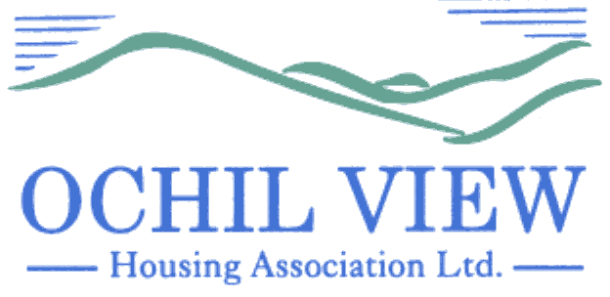

NOTICE OF BOARD OF MANAGEMENT MEETING TO BE HELD AT OCHIL HOUSE (AND REMOTELY VIA MS TEAMS) ON THURSDAY 25th JULY 2024 at 6pm

AGENDA

- Recording of Meeting (No Papers)
FOR APPROVAL / TO BE MINUTED

- Apologies

- Declarations of Interest (No Papers)
TO BE RECORDED

- Minutes of the Board of Management Meeting held on 27th June 2024 (Enclosed)
FOR APPROVAL AND SIGNATURE

- Matters Arising from Item 4.0

- Commercially Sensitive Minute of the Board of Management Meeting held on 27th June 2024 (Enclosed) FOR APPROVAL AND SIGNATURE

- Matters Arising from Item 6.0

- Impairment Review for 2023/2024 (Report from the Director of Finance and Corporate Services Enclosed) FOR APPROVAL

- Audited Accounts for the year end 31st March 2024 (Report from the Director of Finance and Corporate Services Enclosed)
FOR APPROVAL

  - Annual Accounts Report 2024 (Report from the Director of Finance and Corporate Services Enclosed) FOR INFORMATION
  - Letter of Representation to Auditors Alexander Sloan FOR APPROVAL AND SIGNATURE
  - Financial Statements for the year ended 31st March 2024 (To be presented by Alexander Sloan) FOR APPROVAL AND SIGNATURE
  - Management Letter FOR INFORMATION

- Appointment of External Auditors (No Papers)
FOR APPROVAL

11.0 Management Accounts for Period 1st April to 30th June 2024 (Report from the Director of Finance and Corporate Services) FOR APPROVAL

- Quarterly Management Reports for Period 1st April to 30th June 2024 (Reports from the Chief Executive Enclosed) FOR APPROVAL

  - Corporate Performance Report
  - Corporate Management Plan Progress
  - Annual Assurance Statement
  - Capital Programme Progress (DEFERRED)
  - Resident Safety Compliance Report

- Strategic Risk Management (Report from the Chief Executive Enclosed)
FOR APPROVAL

- Annual General Meeting Report (2) (Report from the Chief Executive Enclosed)
FOR APPROVAL

- Board Nominees Affected by the 9 Year Rule (Report from the Chief Executive Enclosed) FOR APPROVAL

- Annual Declaration of Compliance with Rules 62 to 67 (Report from the Chief Executive Enclosed) FOR APPROVAL

- Flexible Working Trial (Report from the Chief Executive Enclosed) FOR APPROVAL

- Minutes of the Customer Services Meeting of 6th June 2024 (Enclosed) FOR INFORMATION

18.1 Allocations Policy FOR APPROVAL
18.2 Property Factoring Policy FOR APPROVAL

- Minutes of the Finance, Audit & Corporate Governance Committee Meeting of 11th July 2024 (Enclosed) FOR INFORMATION

  - Verbal Report from the Convenor (No Papers)
  - Risk Management Framework (Review) FOR APPROVAL

- Governance / Other Board Training Issues
FOR INFORMATION

  - Board Training Programme 2024-2025
  - SFHA Board Member Application
  - SFHA Representative – Ochil View

- EVH Business:

  - EVH Monthly Report: July 2024 (Enclosed)

- A.O.C.B

Board Member Registration of Interest

- Date of Next Meeting 29th August 2024

Anne Smith
Chief Executive
18th July 2024

NB

Please note that it would be appreciated if any typographical errors etc could be communicated to me prior to the meeting (preferably by email) so that the relevant amendments can be made in advance of the meeting. Thanks

