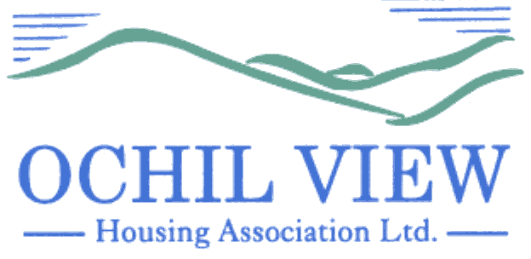

NOTICE OF BOARD OF MANAGEMENT MEETING TO BE HELD AT OCHIL HOUSE AND VIA MS TEAMS ON THURSDAY 31st OCTOBER 2024 at 6pm

AGENDA

- Recording of Meeting (No Papers)
FOR APPROVAL / TO BE MINUTED

- Apologies

- Declarations of Interest (No Papers)
TO BE RECORDED

- Minutes of Meeting held on 26th September 2024 (Enclosed)
FOR APPROVAL AND SIGNATURE

- Matters Arising

- Commercially Sensitive Minutes of Meeting held on 26th September 2024 (Enclosed)
FOR APPROVAL AND SIGNATURE

- Matters Arising

- Management Accounts for Period 1st July to 30th September 2024 (Report from the Director of Finance and Corporate Services) FOR APPROVAL

- Quarterly Management Reports for Period 1st July to 30th September 2024 (Reports from the Chief Executive Enclosed) FOR APPROVAL

  - Corporate Performance
  - Corporate Management Plan Progress
  - Annual Assurance Statement (DEFERRED)
  - Capital Programme Progress
  - Resident Safety Compliance Report

- Strategic Risk Management 2024/2025 (Q2) (Report from the Chief Executive Enclosed) FOR APPROVAL

- Adaptations Funding and Budget (Report from the Director of Property Services) FOR APPROVAL

- Governance / Board Training Matters
FOR DISCUSSION / INFORMATION/CONSIDERATION

  - Board members Code of Conduct and Declarations of Interest Update (No Papers)
  - Note of Board Session 3rd October 2024 (SHN Performance Analysis) (Enclosed) FOR INFORMATION

- EVH Business
FOR INFORMATION / CONSIDERATION

  - Monthly Report for October 2024 (Enclosed)

- Christmas Meal: Board (No papers) FOR DISCUSSION

- A.O.C.B

- Date of Next Meeting 28th November 2024

Anne Smith
Chief Executive

27th September 2024

NB
Please note that it would be appreciated if any typographical errors etc could be communicated to me prior to the meeting (preferably by email) so that the relevant amendments can be made in advance of the meeting. Thanks

