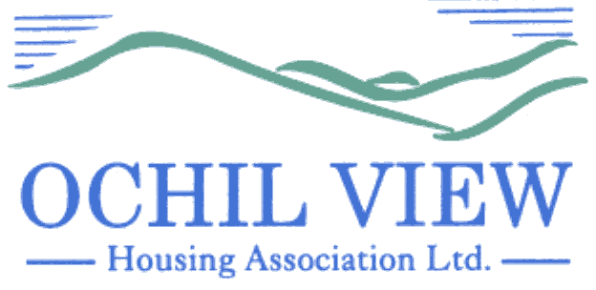

NOTICE OF BOARD OF MANAGEMENT MEETING TO BE HELD AT OCHIL HOUSE (AND REMOTELY VIA MS TEAMS) ON THURSDAY 27th JULY 2023 at 6pm

AGENDA

- Recording of Meeting (No Papers)
FOR APPROVAL / TO BE MINUTED

- Apologies

- Declarations of Interest (No Papers)
TO BE RECORDED

- Minutes of the Board of Management Meeting held on 29th June 2023 (Enclosed)
FOR APPROVAL AND SIGNATURE

- Matters Arising from Item 4.0

- Commercially Sensitive Extract of the Minutes of the Board of Management Meeting held on 29th June 2023 (Enclosed) FOR APPROVAL AND SIGNATURE

- Matters Arising from Item 6.0

- Private and Confidential Minute of the Board of Management Meeting on 29th June 2023 (Enclosed) FOR APPROVAL AND SIGNATURE

- Matters Arising from Item 8.0

- Impairment Review for 2022/2023 (Report from the Director of Finance and Corporate Services Enclosed) FOR APPROVAL

- Audited Accounts for the year end 31st March 2023 (Report from the Director of Finance and Corporate Services Enclosed)
FOR APPROVAL

  - Annual Accounts Report 2023 (Report from the Director of Finance and Corporate Services Enclosed) FOR INFORMATION
  - Latest Draft Financial Statements 2023 (Enclosed)
  - Letter of Representation to Auditors Alexander Sloan FOR APPROVAL AND SIGNATURE
  - Financial Statements for the year ended 31st March 2023 (To be presented by Alexander Sloan) FOR APPROVAL AND SIGNATURE
  - Management Letter FOR SIGNATURE

- Appointment of External Auditors (No Papers)
FOR APPROVAL

- Management Accounts for Period 1st April to 30th June 2023 (Report from Director of Finance and Corporate Services) FOR APPROVAL

- Quarterly Management Reports for Period 1st April to 30th June 2023 (Reports from the Chief Executive Enclosed) FOR APPROVAL

  - Corporate Performance Report
  - Corporate Management Plan Progress
  - Annual Assurance Statement
  - Capital Programme Progress

- Strategic Risk Management (Report from the Chief Executive Enclosed)
FOR APPROVAL

- AAS Compliance Report (Report from the Director of Property Services) FOR APPROVAL

- Annual General Meeting Report (2) (Report from the Chief Executive Enclosed)
FOR APPROVAL

- Board Nominees Affected by the 9 Year Rule (Report from the Chief Executive Enclosed) FOR APPROVAL

- Annual Declaration of Compliance with Rules 62 to 67 (Report from the Chief Executive Enclosed) FOR APPROVAL

- Minutes of the Finance, Audit & Corporate Governance Committee Meeting of 13th July 2023 (Enclosed) FOR INFORMATION

  - Verbal Report from Convenor (No Papers)
  - Risk Management Framework (Review) FOR APPROVAL

- Governance / Other Board Training Issues
FOR INFORMATION

  - Reminder of Board Training Session Scheduled for 31st August 2023
  - Board Training Programme 2023-2024
  - SFHA Board Director Nominations (Enclosed)
  - SFHA Fee System Review
  - Application for Membership and recommendation to co-opt Member to the Board of Management FOR APPROVAL

- EVH Business: Announcement re new Director (Enclosed)
FOR INFORMATION

- A.O.C.B

- Date of Next Meeting 28th September 2023

Anne Smith
Chief Executive
21ST July 2023

NB

Please note that it would be appreciated if any typographical errors etc could be communicated to me prior to the meeting (preferably by email) so that the relevant amendments can be made in advance of the meeting. Thanks

