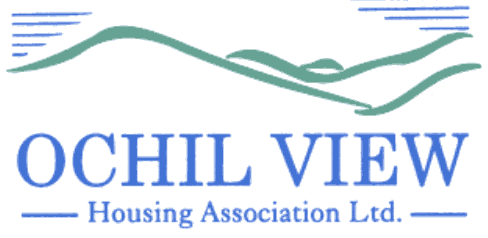

NOTICE OF BOARD OF MANAGEMENT MEETING TO BE HELD ON THURSDAY 28th SEPTEMBER 2023 at 6pm AT OCHIL HOUSE, ALLOA AND ON MS TEAMS

AGENDA

- Recording of Meeting (No Papers)
FOR APPROVAL / TO BE MINUTED

- Election of Office Bearers (No Papers)
FOR DECISION

  - Chairperson
  - Vice Chairperson
  - Treasurer

- Apologies

- Leave of Absence – Extension (No Papers)
FOR DECISION

- Declarations of Interest (No Papers)
TO BE RECORDED

- Minutes of Board of Management meeting held on 27th July 2023 (Enclosed)
FOR APPROVAL AND SIGNATURE

- Matters Arising from Item 6.0

- Commercially Sensitive Extract of the Board of Management meeting held on 27th July 2023 (Enclosed)
FOR APPROVAL AND SIGNATURE

- Matters Arising from Item 8.0

- P&C Minutes of the Executive Committee Meeting held on 29th August 2023 (Enclosed) FOR APPROVAL AND SIGNATURE

- Matters Arising from Item 10.0

- P&C Minutes of the Executive Committee Meeting held on 7th September 2023 (Enclosed) FOR APPROVAL AND SIGNATURE

- Matters Arising from Item 12.0

- Draft Minute of AGM 14th September 2023 (Enclosed) FOR INFORMATION

- Committee Remits and Composition of Board / Committees 2023/2024 (Report from the Chief Executive Enclosed) FOR APPROVAL

- Code of Conduct for Governing Body Members 2023 (Report from the Chief Executive Enclosed) FOR APPROVAL & ACTION

- Board of Management Declarations of Interest (Report from the Chief Executive Enclosed) FOR ACTION

- Entitlements, Payments and Benefits Allocation (Report from the Director of Housing Services) FOR APPROVAL

- Annual Assurance Statement Compliance Report (Report from the Director of Property Services) FOR APPROVAL

- Annual Assurance Statement 2023 (Report from the Chief Executive Enclosed)
FOR APPROVAL

- Staffing Review 2023-2024 (Report from the Chief Executive Enclosed) FOR APPROVAL

- Minutes of the HSEHR Committee meeting held on 10th August 2023 (Enclosed) FOR INFORMATION

22.1 Landlord Safety Manual FOR APPROVAL
22.2 Dignity at Work Policy Review FOR APPROVAL

- Minutes of the Finance, Audit and Corporate Governance Committee Meeting held on 7th September 2023 (Enclosed) FOR INFORMATION

23.1 Whistleblowing Policy FOR APPROVAL
23.2 Board Induction Policy FOR APPROVAL

- Governance/Other Issues

  - Note of Board Training 31st August 23 (Enclosed) FOR INFORMATION
  - Annual Report 2022-2023 (Enclosed) FOR INFORMATION
  - Governing Body Forums/Conference (Enclosed) FOR INFORMATION
  - SHR Landlord Report (Enclosed) FOR INFORMATION
  - Alloa First Business Plan/Ballot (Enclosed) FOR DECISION

- EVH Monthly Report:
25.1 August 2023 (Enclosed) FOR INFORMATION
25.2 September 2023 (Enclosed) FOR INFORMATION

- EVH Salaries Consultation (Enclosed) FOR RESPONSE

- AOCB

- Date of Next Meeting 26th October 2023

Anne Smith
Chief Executive

19th September 2023
NB
Please note that it would be appreciated if any typographical errors etc could be communicated to me prior to the meeting (preferably by email) so that the relevant amendments can be made in advance of the meeting. Thanks

